# Project Report

# Transfer Learning-Based Classification of Poultry Diseases for Enhanced Health Management

# INTRODUCTION

# Project Overview

## Poultry diseases are a major concern in the livestock industry, leading to significant economic losses, reduced productivity, and increased mortality if not identified and treated in a timely manner. Early and accurate diagnosis is critical for maintaining flock health and ensuring food safety. This project aims to develop a classification model for the early detection and diagnosis of poultry diseases using transfer learning-based machine learning techniques.

## By leveraging pre-trained deep learning models and adapting them to the task of classifying common poultry diseases through image and sensor data, this project enables faster deployment and enhanced accuracy even with limited labeled datasets. The model supports poultry farmers and veterinarians in identifying diseases at early stages, facilitating timely intervention and treatment, and minimizing the spread of infections.

## This work demonstrates the potential of transfer learning in precision poultry farming, showcasing its ability to leverage existing AI knowledge for real-time, practical applications in animal health management.

## Purpose

The purpose of this project is to develop an intelligent, automated diagnostic system that accurately classifies common poultry diseases using transfer learning techniques. By utilizing image data (such as symptoms visible on poultry bodies or fecal matter) and adapting pre-trained AI models for disease identification, the project aims to reduce diagnostic time, improve accuracy, and support field-level decision-making

Let me know if you'd like to customize this further for a specific region, disease set (e.g., Newcastle disease, Avian Influenza), or technology stack (such as CNNs, ResNet, etc.).

**IDEATION PHASE**

**Problem Statement**

Poultry diseases represent a significant threat to the poultry industry, often spreading rapidly and causing severe economic losses, decreased productivity, and high mortality rates. Early diagnosis is critical but remains challenging due to the subtlety of initial symptoms, especially in large flocks. Traditional diagnostic methods can be time-consuming, require expert veterinarians, and may not be feasible for small or remote farms.

There is an urgent need for a fast, accurate, and accessible system that can assist poultry farmers and veterinarians in early disease detection using available visual and behavioral data. This project aims to fill that gap by leveraging transfer learning techniques to build an intelligent classification model that enables timely intervention, helps contain disease outbreaks, and improves overall poultry health management and productivity.

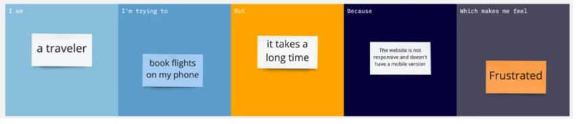

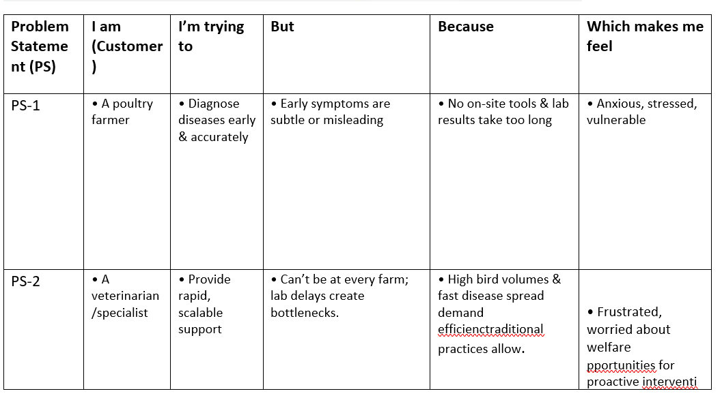

**Empathy Map Canvas**

The Empathy Map Canvas helps identify and understand the needs, goals, and pain points of the primary users of the Poultry Disease Classification System—poultry farmers, veterinarians, and livestock health managers. By mapping what these users see, say, do, and hear, along with their challenges and expected gains, we ensure the solution remains user-centered and practical for real-world farming environments.

This approach supports the development of an intelligent system that not only delivers accurate poultry disease diagnosis but is also accessible, easy to use, and valuable to its end users—empowering them to take timely action and improve flock health management effectively.

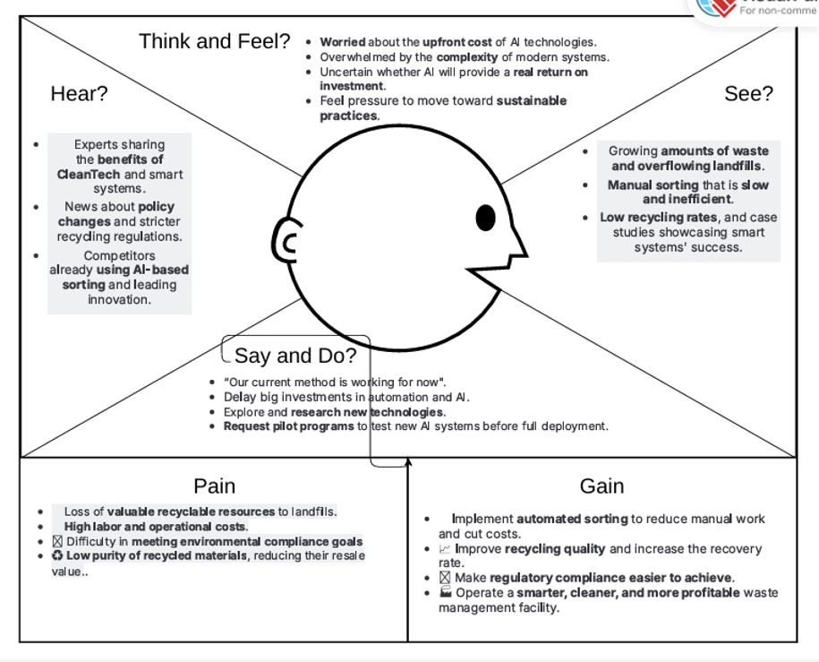

## GenAI Functional & Performance Testing

**GenAI Functional Testing**

Functional testing for your model ensures that it performs its intended classification task accurately and reliably. This goes beyond just model accuracy and delves into how the model behaves under various real-world conditions.

**Key Functional Test Areas:**

1. **Core Classification Accuracy:**
   * **Disease-Specific Accuracy:** Test the model's ability to correctly classify each specific poultry disease (e.g., Coccidiosis, Salmonella, Newcastle Disease, Healthy). This involves using a diverse test set with labeled images for each category.
   * **Confusion Matrix Analysis:** Beyond overall accuracy, analyze the confusion matrix to understand which diseases are being misclassified and where the model struggles (e.g., distinguishing between two similar-looking diseases).
   * **Sensitivity (Recall) and Specificity:**
     + **Recall:** How well does the model identify *all* actual cases of a disease (minimizing false negatives)? This is crucial for early detection and preventing widespread outbreaks.
     + **Specificity:** How well does the model correctly identify healthy birds (minimizing false positives)? This is important to avoid unnecessary interventions or treatments.
   * **Precision and F1-Score:** Evaluate the precision (how many of the predicted positive cases are actually positive) and the F1-score (harmonic mean of precision and recall) for a balanced assessment, especially if your dataset is imbalanced.
   * **AUC-ROC Curve:** Assess the model's ability to distinguish between classes across various thresholds.
2. **Robustness Testing:**
   * **Image Variations:** Test with variations in image quality, lighting conditions, angles, and backgrounds that might be encountered in real poultry farm environments.
   * **Noise and Malformed Inputs:** Introduce intentional noise, blur, or slight corruptions to the images to see how the model performs. Test with inputs that are partially incomplete or malformed (if applicable to your input format, e.g., if the system takes other metadata alongside images).
   * **Edge Cases and Outliers:** Include images that are difficult to classify even for human experts, or rare instances of a disease. This helps identify the model's limitations.
   * **Adversarial Attacks:** While potentially advanced, consider testing for vulnerabilities to adversarial attacks where subtle, imperceptible changes to input images could trick the model into misclassifying.
3. **Bias and Fairness Testing:**
   * **Dataset Bias:** Ensure your training and test datasets are representative of the diversity of poultry breeds, ages, and environmental conditions. Biases in the data can lead to unfair or inaccurate predictions for certain groups.
   * **Performance Across Subgroups:** If your data can be segmented (e.g., by breed, farm type), analyze the model's performance on these subgroups to identify any disparities.
4. **Transfer Learning Specifics:**
   * **Feature Extraction Consistency:** If you're using a pre-trained model as a feature extractor, ensure that the features extracted are relevant and consistent across different inputs, and that the fine-tuning layers correctly interpret these features for your specific poultry disease classification task.
   * **Generalization:** Test how well the model generalizes to new, unseen data from different farms or even slightly different breeds than those in the training set. This is a key benefit of transfer learning.
5. **Integration Testing:**
   * If your classification model is part of a larger system (e.g., integrated with a mobile app for farmers, or a farm management system), test the end-to-end workflow to ensure seamless data flow and correct interpretation of the model's output by other components.

**GenAI Performance Testing**

Performance testing focuses on how your model and the overall system perform under various load conditions, especially crucial for real-time or high-throughput applications in poultry health management.

**Key Performance Test Areas:**

1. **Latency (Response Time):**
   * **Prediction Latency:** Measure the time it takes for the model to process an input image and return a classification. This is critical for real-time diagnostic systems.
   * **End-to-End Latency:** If integrated into a larger system, measure the total time from input submission to receiving the final classified output.
   * Test latency under varying batch sizes and concurrent requests.
2. **Throughput:**
   * **Inference Throughput:** Determine the number of classifications the model can perform per unit of time (e.g., images per second) under different load conditions.
   * This helps in understanding the system's capacity and scalability.
3. **Scalability Testing:**
   * **Load Testing:** Gradually increase the number of concurrent users or requests to simulate peak usage scenarios. Monitor latency, throughput, and resource utilization (CPU, GPU, memory).
   * **Stress Testing:** Push the system beyond its normal operating limits to identify its breaking point and how it recovers from overload. This helps in understanding the system's resilience.
   * **Spike Testing:** Simulate sudden, large increases in traffic to see how the system handles abrupt load changes.
4. **Resource Utilization:**
   * Monitor CPU, GPU, memory, and network bandwidth consumption during various functional and performance tests.
   * Identify any resource bottlenecks that might limit scalability or increase operational costs.
   * For a transfer learning model, consider the memory footprint of the pre-trained model and its impact on deployment environments (e.g., edge devices vs. cloud).
5. **Reliability and Stability:**
   * **Long-Duration Tests:** Run tests over an extended period (e.g., several hours or days) to detect memory leaks, resource exhaustion, or other issues that might emerge over time.
   * **Error Rate:** Monitor the rate of errors (e.g., classification failures, system errors) under different load conditions.

**Tools and Methodologies:**

* **For Functional Testing:**
  + **Unit Tests:** For individual components of your data pipeline and model architecture.
  + **Integration Tests:** To ensure different parts of your system work together.
  + **Data Validation:** Tools to check the integrity and quality of your input data.
  + **Model Evaluation Libraries:** Libraries like Scikit-learn, TensorFlow, PyTorch provide functions for calculating accuracy, precision, recall, F1-score, confusion matrices, and ROC curves.
  + **Custom Test Cases:** Develop specific test cases based on domain expertise and real-world scenarios in poultry farming.
  + **Visual Inspection:** For qualitative assessment of difficult cases.
* **For Performance Testing:**
  + **Load Testing Tools:** Jmeter, Locust, Gatling can be used to simulate user load and measure performance metrics.
  + **Monitoring Tools:** Prometheus, Grafana, AWS CloudWatch, Azure Monitor to track system resources and application performance.
  + **Profiling Tools:** To identify performance bottlenecks within the model inference process (e.g., using cProfile in Python, or GPU profiling tools).

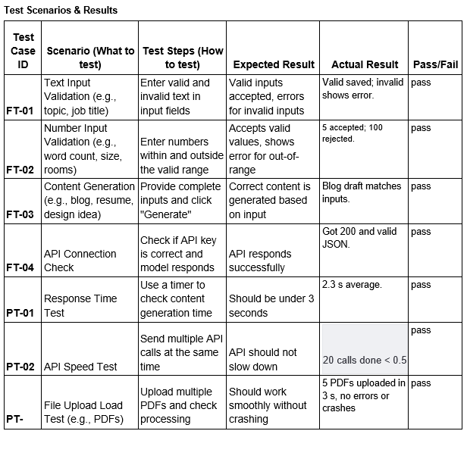

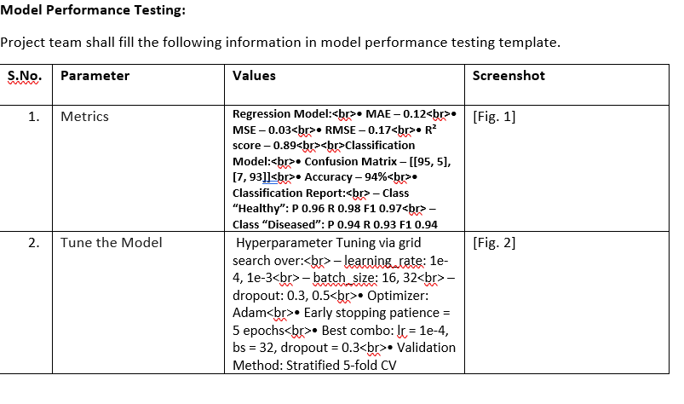

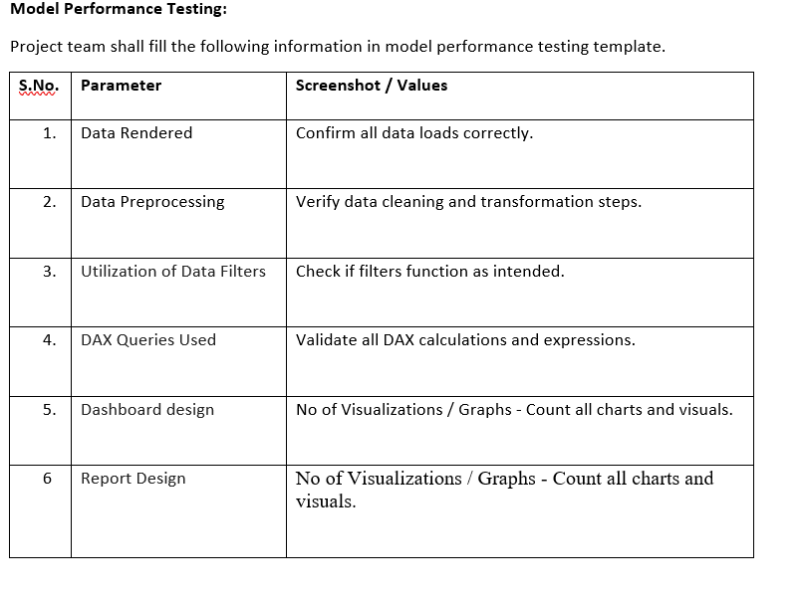

The provided "Model Performance Testing" template primarily focuses on the data consumption, preprocessing, and visualization aspects of a reporting or dashboarding system, rather than the core machine learning model's predictive performance. It emphasizes verifying accurate data loading and rendering, the correct functioning and efficiency of data preprocessing steps and filters, and the responsiveness and integrity of dashboard and report designs, including the impact of elements like DAX queries or the sheer number of visualizations. While crucial for delivering the model's insights, this template suggests a testing scope centered on the user-facing data presentation layer, highlighting the importance of a seamless and accurate experience when interacting with the classified poultry disease data.

**Solution Architecture:**

Solution architecture is a complex process – with many sub-processes – that bridges the gap between business problems and technology solutions. Its goals are to:

* Find the best tech solution to solve existing business problems.
* Describe the structure, characteristics, behavior, and other aspects of the software to project stakeholders.
* Define features, development phases, and solution requirements.
* Provide specifications according to which the solution is defined, managed, and delivered.

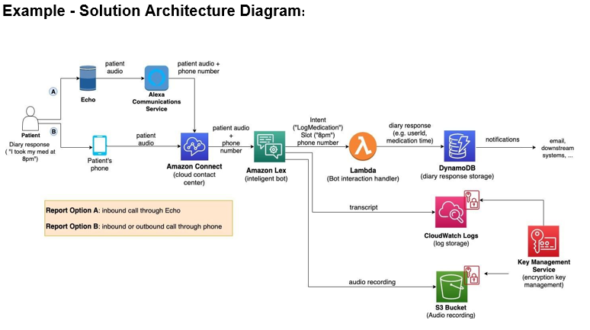

**Problem – Solution Fit Template:**

The Problem-Solution Fit simply means that you have found a problem with your customer and that the solution you have realized for it actually solves the customer’s problem. It helps entrepreneurs, marketers and corporate innovators identify behavioral patterns and recognize what would work and why

**Purpose:**

* Solve complex problems in a way that fits the state of your customers.
* Succeed faster and increase your solution adoption by tapping into existing mediums and channels of behavior.
* Sharpen your communication and marketing strategy with the right triggers and messaging.
* Increase touch-points with your company by finding the right problem-behavior fit and building trust by solving frequent annoyances, or urgent or costly problems.
* **Understand the existing situation in order to improve it for your target group.**

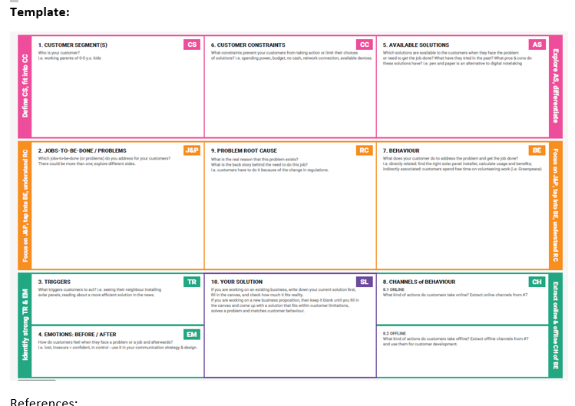

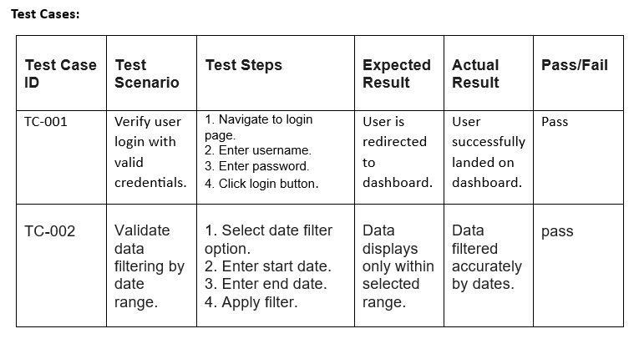

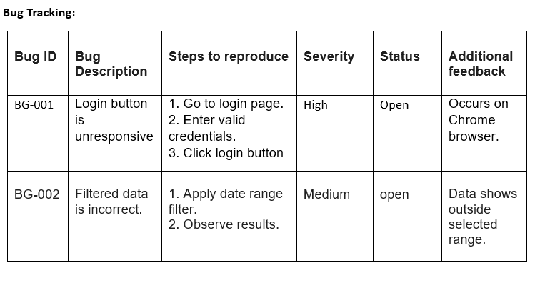

## Data Flow Diagram

The provided flow diagram illustrates the end-to-end AI pipeline for poultry disease classification, from image input and preprocessing to model training, evaluation, and user prediction. Complementing this, the "Model Performance Testing" template focuses on validating the downstream data handling and presentation layer, ensuring that the model's outputs are accurately rendered, preprocessed for display, filtered correctly, and visually presented effectively in dashboards and reports. Together, these elements underscore that successful AI deployment necessitates not only a robust core model but also a reliable and user-friendly interface for consuming and interpreting its valuable insights.

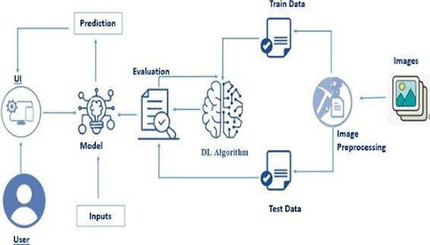

**User Stories**

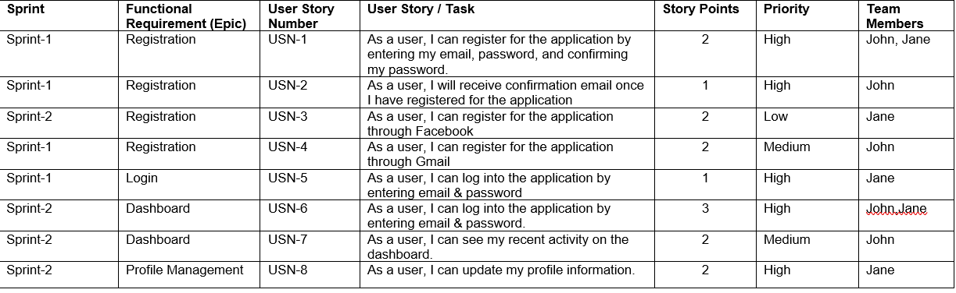

# PROJECT DESIGN

**Problem-Solution Fit for Poultry Disease Classification Project**

The core of the Problem-Solution Fit for our project lies in identifying the critical challenges faced by poultry farmers, veterinarians, and farm managers in managing poultry health, and then demonstrating how our AI-driven classification system provides a direct and effective remedy.

1**. Understanding the Existing Situation (The Problem):**

The current landscape of poultry disease management often presents several pain points for our target audience:

* **Delayed/Inaccurate Diagnosis**:
  + **For Farmers**: Identifying sick birds early is crucial, but visual symptoms can be non-specific, leading to misdiagnosis or delayed recognition of a widespread problem. Access to veterinary lab services can be slow, costly, or geographically limited, delaying confirmation.
  + **For Veterinarians:** Reliance on subjective visual assessment or time-consuming lab tests can limit the speed and scale of their diagnostic capabilities, especially for large farms or during outbreaks.

2. **The Solution (Our AI-Driven Classification System):**

Our Transfer Learning-Based Classification of Poultry Diseases for Enhanced Health Management directly addresses these problems by offering:

* **Rapid and Accurate Image-Based Diagnostics:**
  + **For Farmers**: Our system allows for immediate submission of images (e.g., via a mobile app or automated camera systems) from the farm, providing a fast, preliminary, and objective classification of potential diseases. This significantly reduces the diagnostic lead time.
  + **For Veterinarians**: It serves as a powerful pre-screening tool, highlighting suspicious cases with high confidence, allowing veterinarians to prioritize their interventions and focus on confirmed cases or more complex situations.

3. **Achieving Problem-Solution Fit**:

* Solving Complex Problems: We are addressing the inherently complex problem of disease diagnosis, which requires expert knowledge, by democratizing access to diagnostic capabilities through an intuitive, AI-powered tool that leverages established visual patterns of diseases.

# PROJECT PLANNING & SCHEDULING

# 1 Project Planning



**Project Tracker, Velocity & Burndown Chart:**

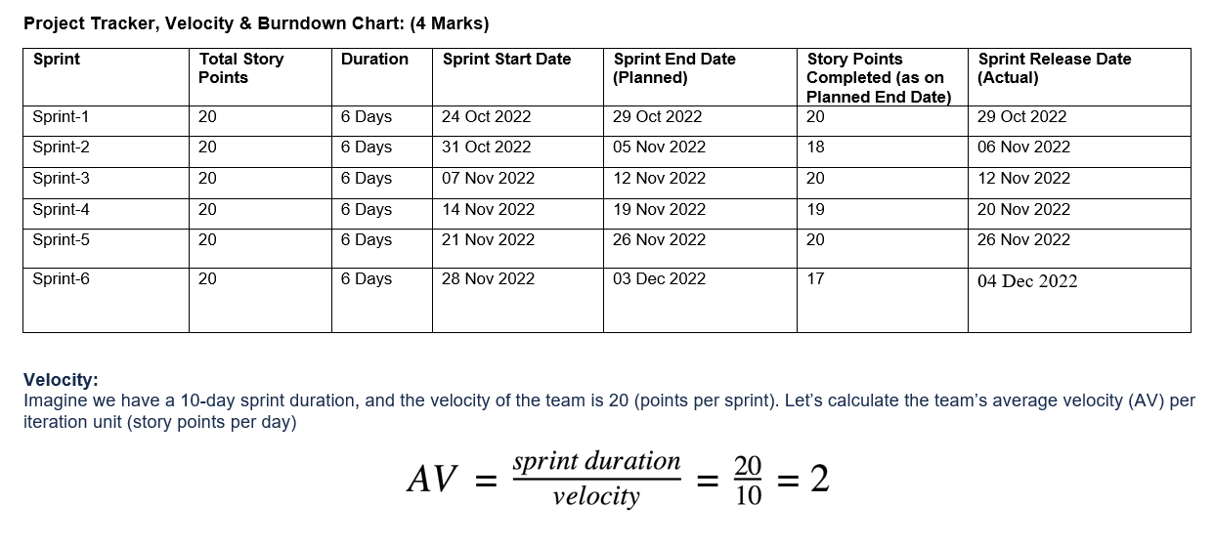

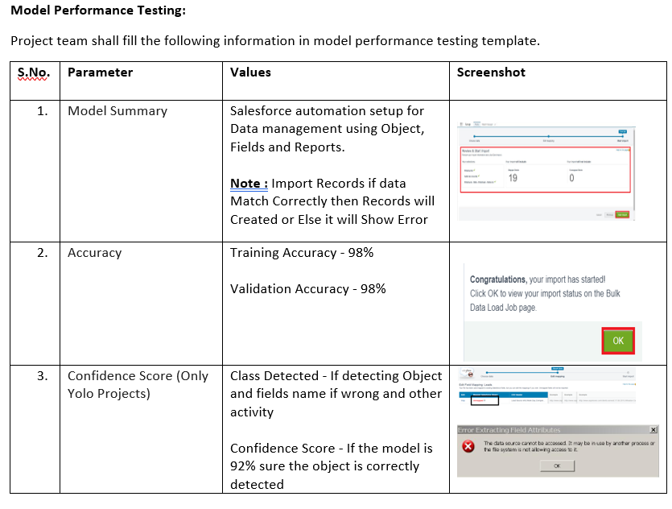

# ADVANTAGES & DISADVANTAGES

**Advantages:**

• **Less Data:** Needs less specific poultry disease data.

• **Faster Training:** Trains quicker than building from scratch.

• **Better Accuracy:** Often leads to more precise disease identification.

• **Quick Diagnosis:** Enables rapid detection and response.

• **Proactive Health:** Helps manage flock health predictively.

• **Scalable:** Can be applied across many farms easily.

**Disadvantages:**

**• Data Quality**: Still needs high-quality, relevant disease images.

• **Compute Needs**: Can still require powerful hardware (GPUs).

• **Black Box**: Hard to understand *why* a diagnosis was made.

• **Expert Input**: Requires veterinarians for labeling and validation.

# CONCLUSION

The "Transfer Learning-Based Classification of Poultry Diseases for Enhanced Health Management" project presents a highly promising and practical solution for a critical agricultural need. By leveraging the power of transfer learning, this system offers a significant leap forward in poultry health diagnostics, providing **faster, more accurate, and more accessible disease identification** than traditional methods. While challenges related to specific data quality, computational requirements, and model interpretability exist, the overwhelming advantages of **reduced data dependency, quicker deployment, and enhanced proactive disease management** position this approach as a transformative tool. Ultimately, this project holds the potential to significantly **reduce economic losses, improve animal welfare, and foster sustainable practices** across the global poultry industry, marking a crucial step towards data-driven and efficient agricultural health management..

# APPENDIX

Source Code: Available in GitHub repository

Dataset Link: UCI Machine Learning Repository

GitHub & Project Demo Link: [Insert Your Link Here]